ASSIGNMENT - 3.5

Name :B.Bharathkumar
Hall Ticket No : 2303a51007
Batch No : 01
Course Title : AI Assisted Coding

Question 1: Zero-Shot Prompting (Leap Year Check)
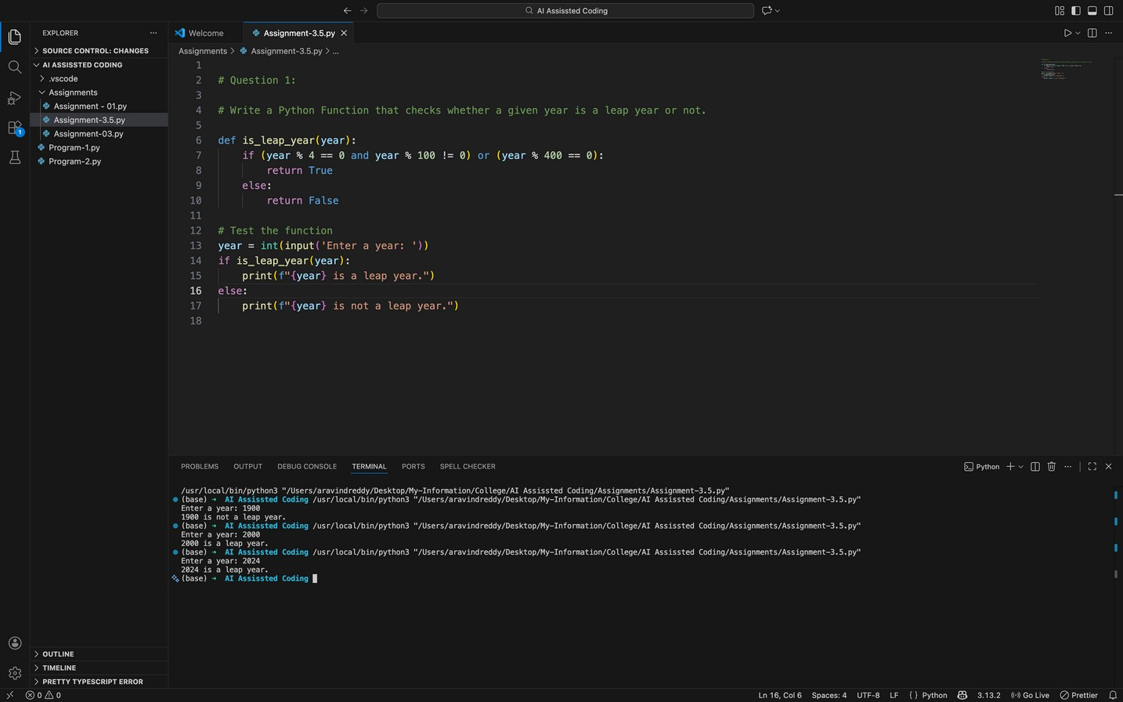
Question 2: One-Shot Prompting (GCD of Two Numbers)
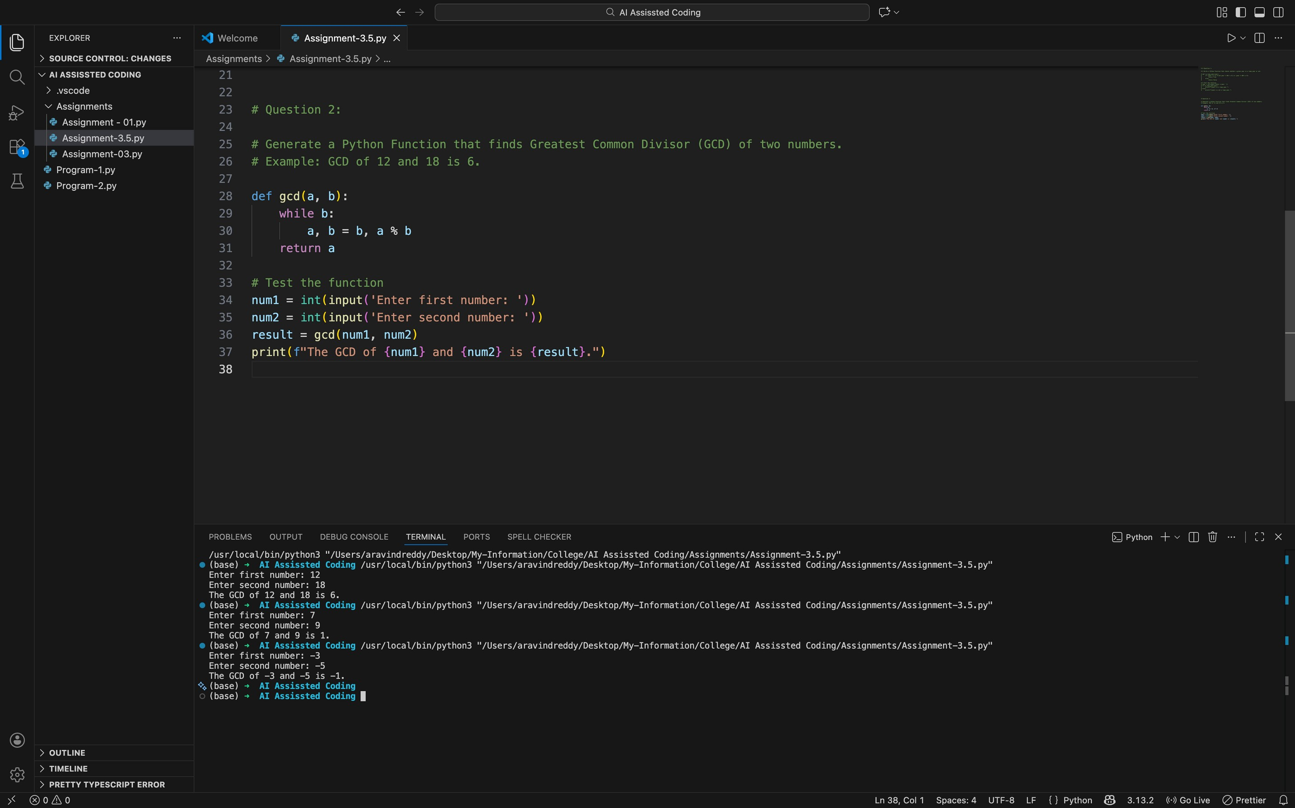
Question 3: Few-Shot Prompting (LCM Calculation)
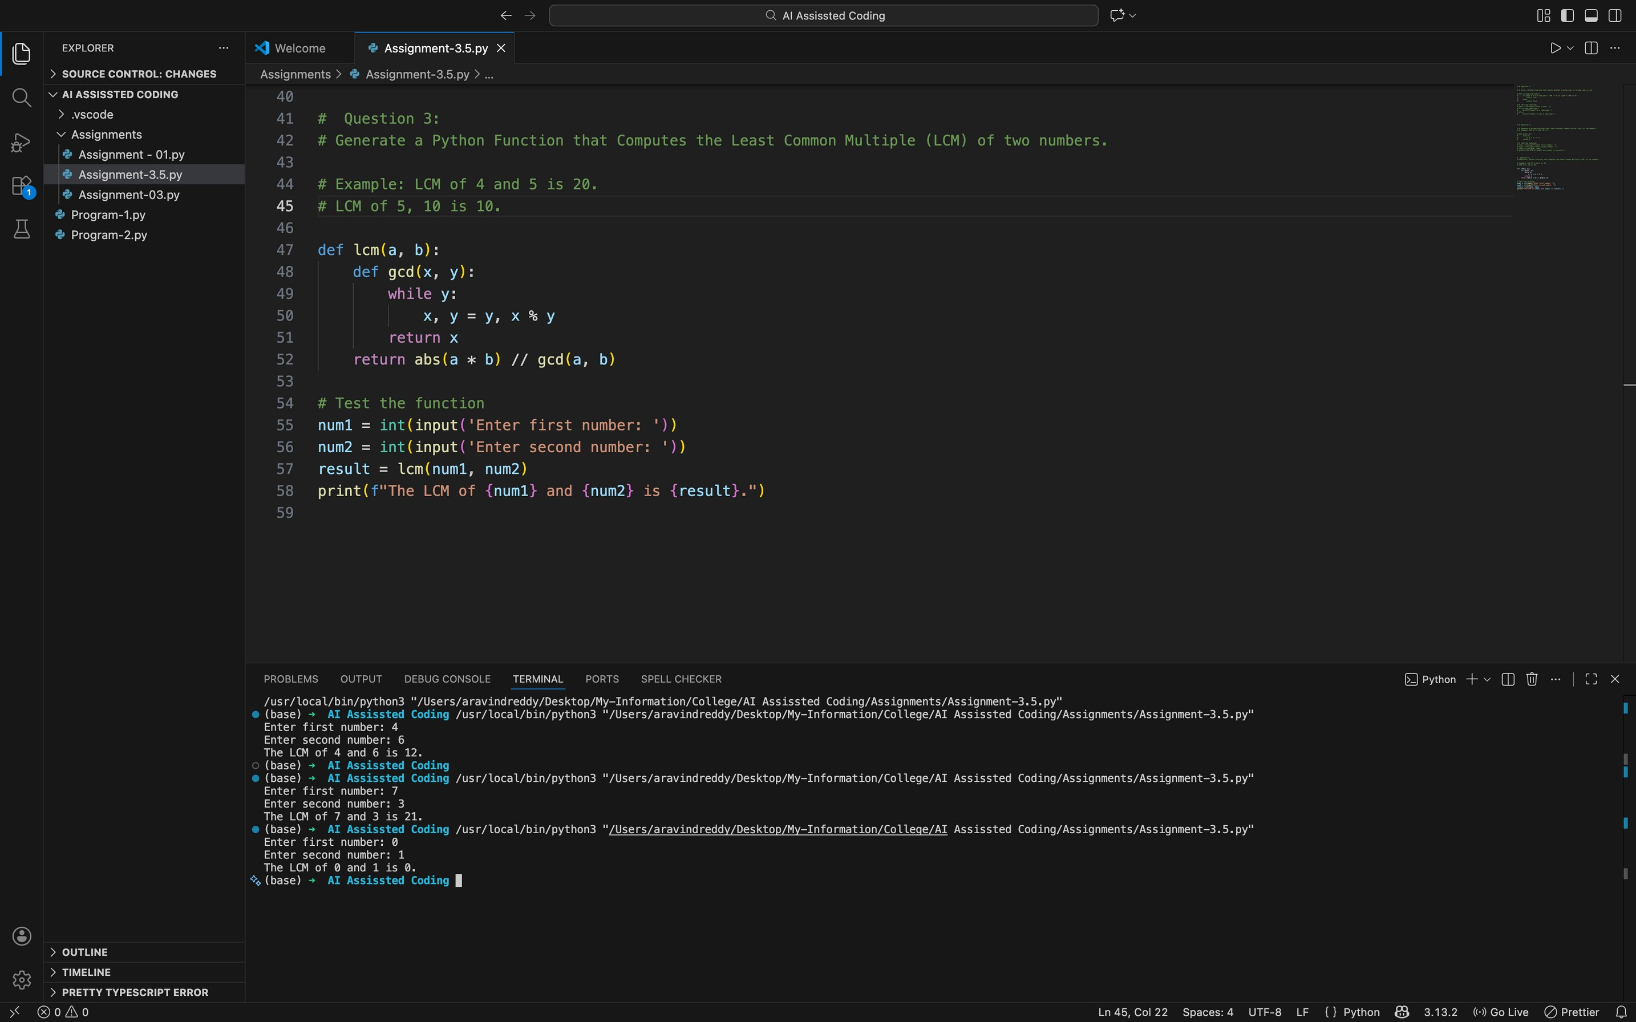
Question 4: Zero-Shot Prompting (Binary to Decimal Conversion)
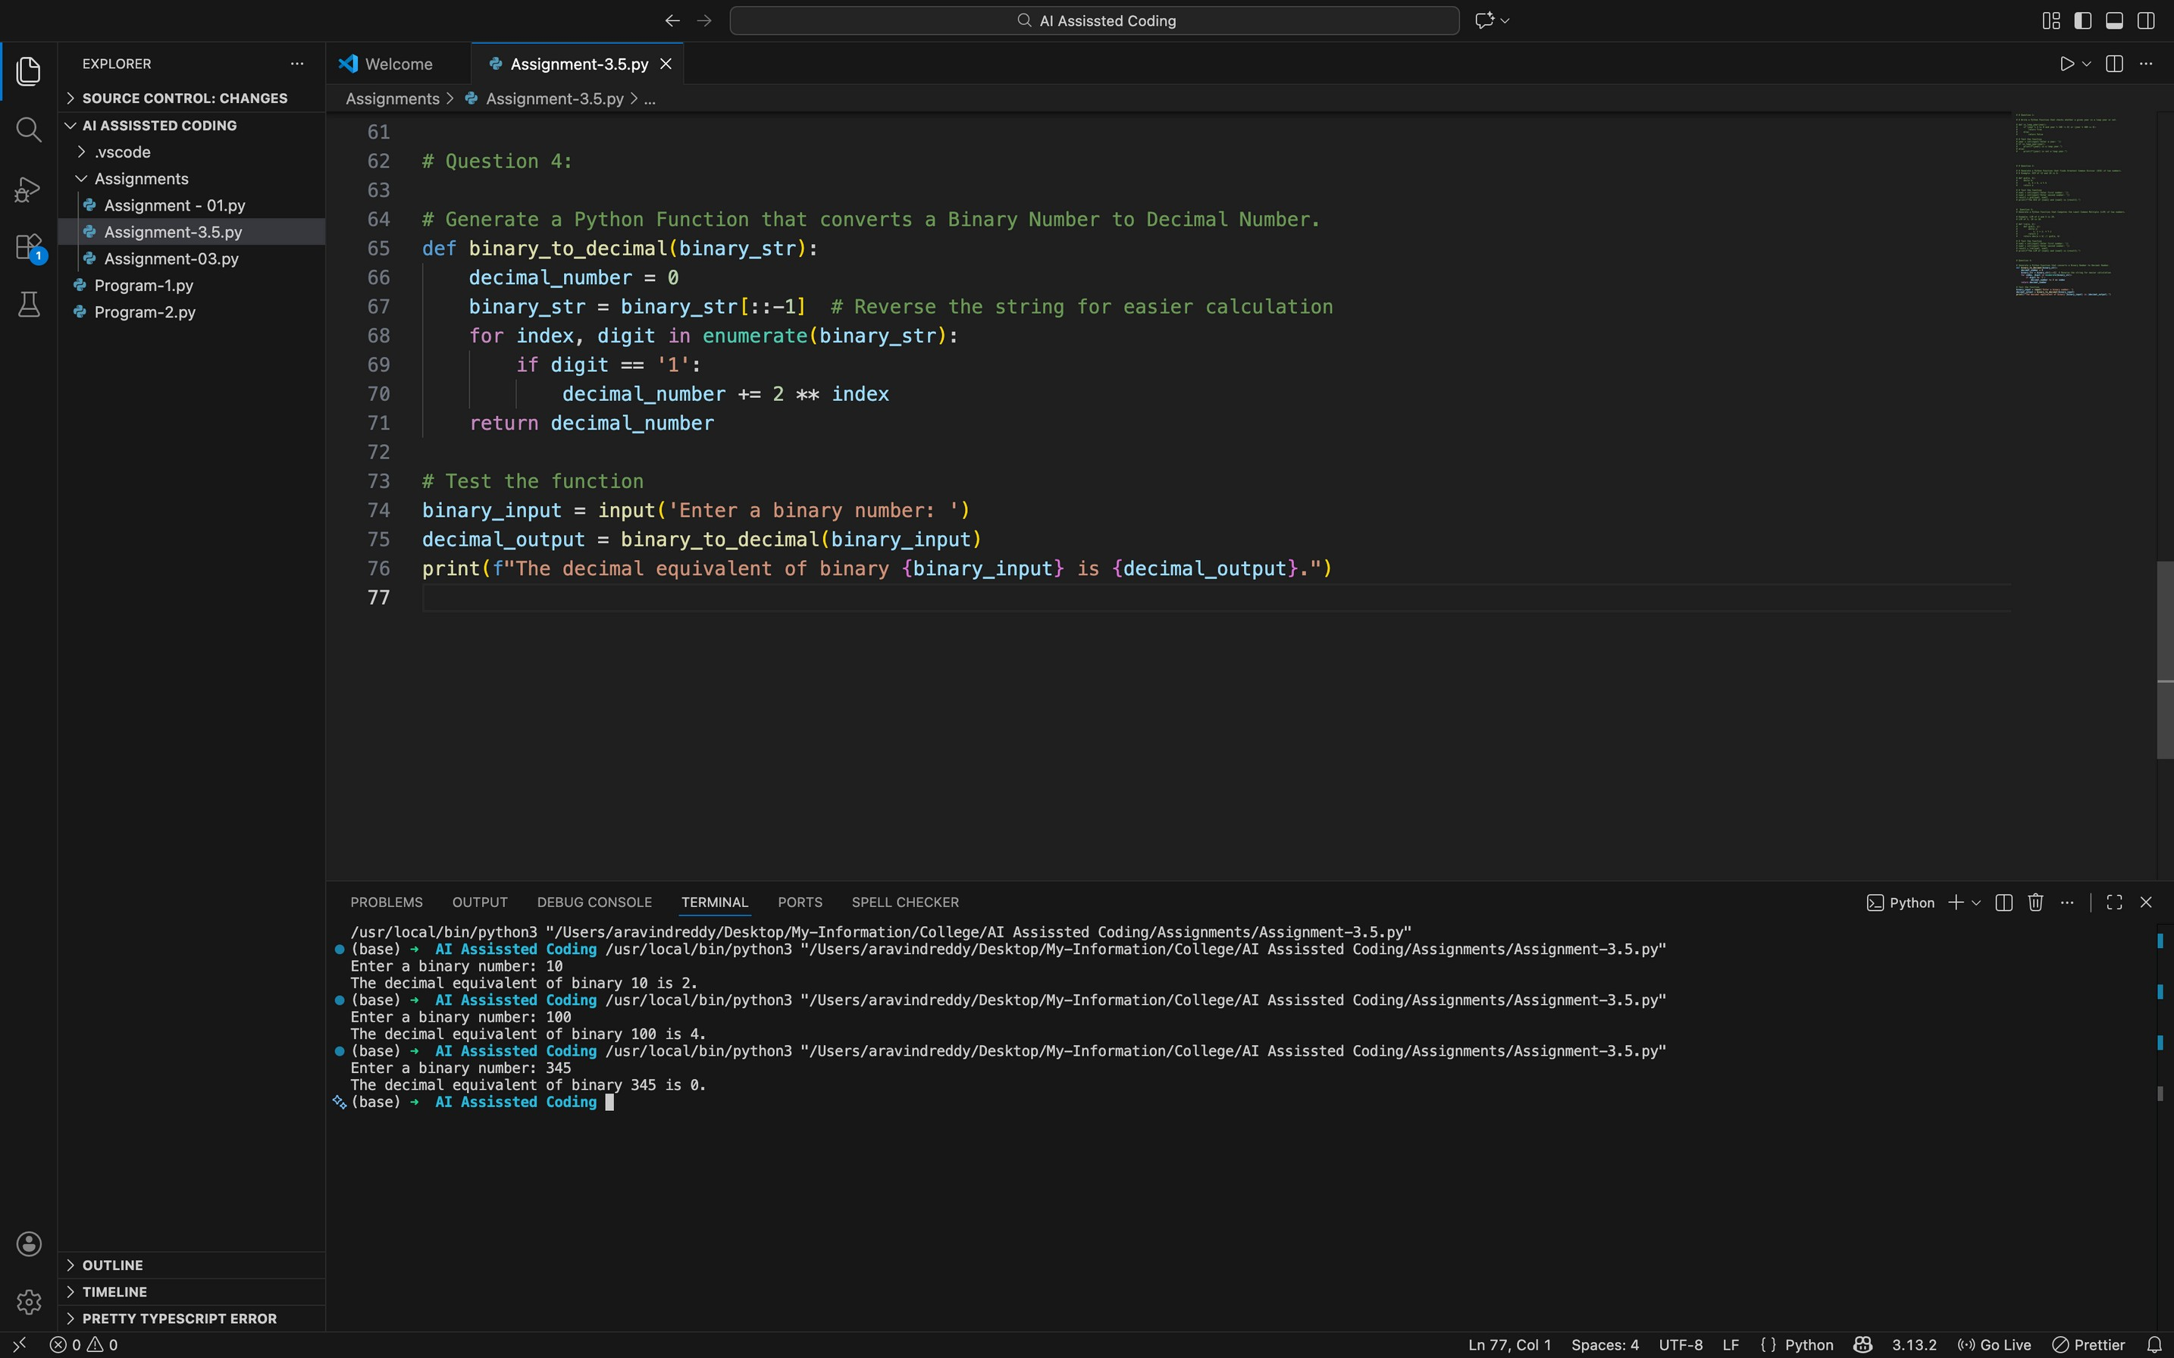
Question 5: One-Shot Prompting (Decimal to Binary Conversion)
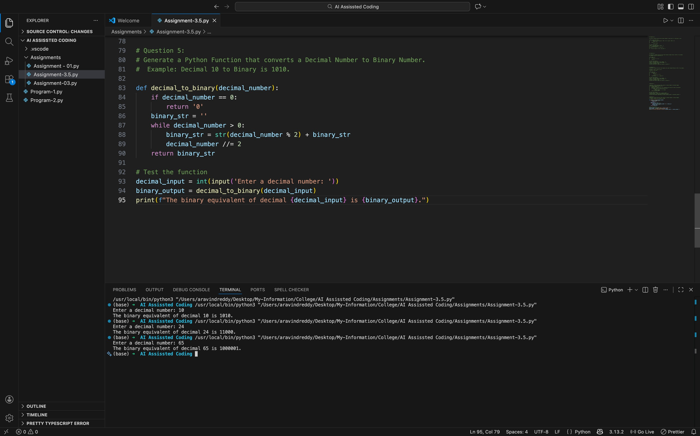
Question 6: Few-Shot Prompting (Harshad Number Check)

